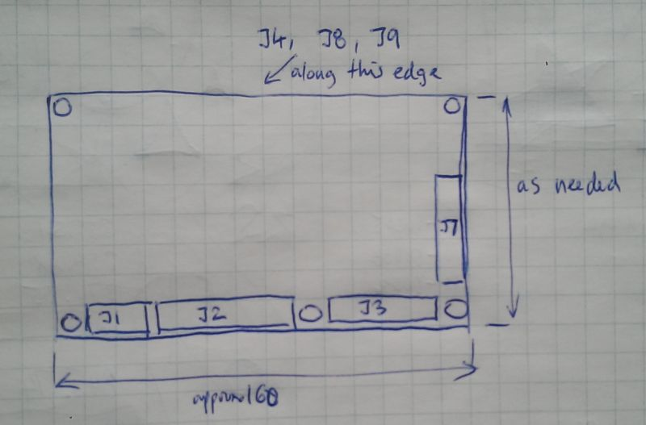


44836001 – Smart Vent
Microcontroller Communication Protocol

Document Version 1.0

Connectors
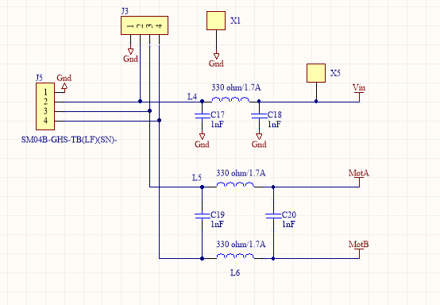
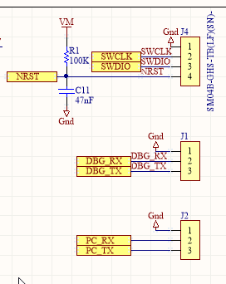

Battery connection:
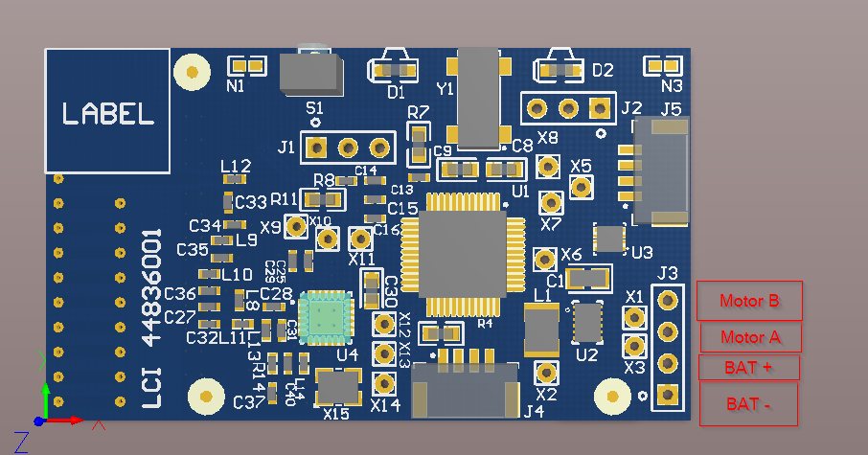

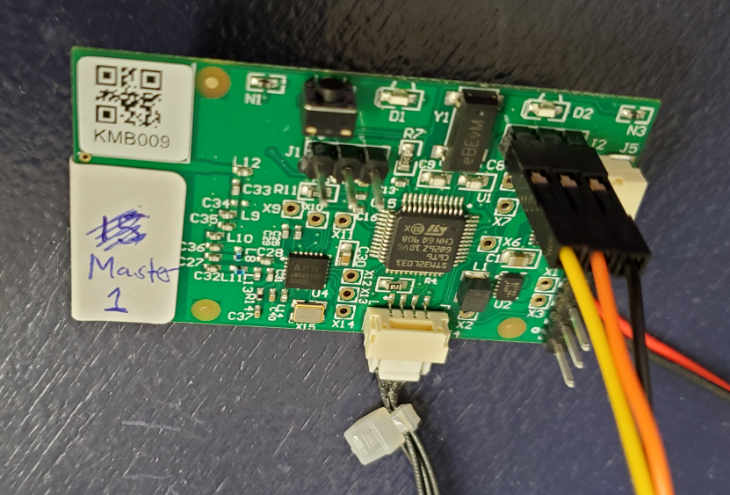
Terminal settings
Putty
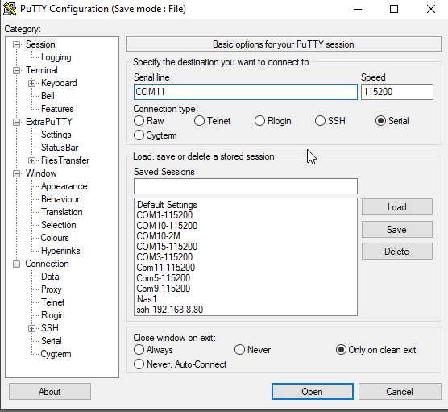
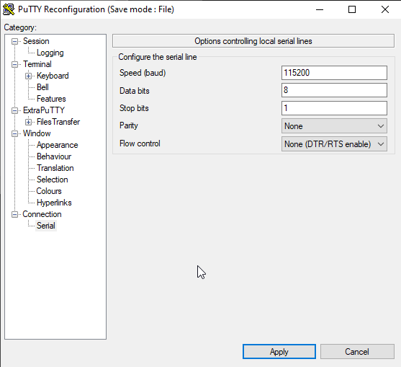
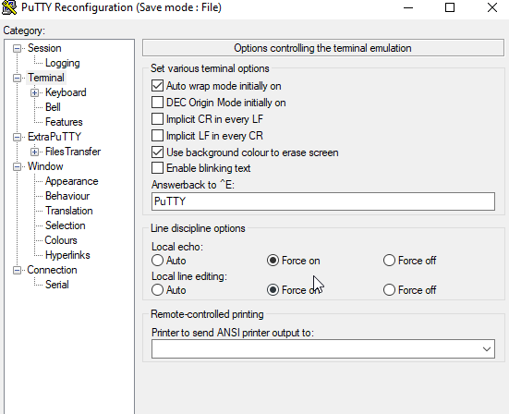

Connect to Board
- Find comm port number in device manager
- Open putty or other terminal application
- Set 115200 baud rate, 1 start, 8 data, 1 stop, no parity, no handshaking
- Connect cable and open port
- Type ping + ENTER, board should respond with “ping ok”. If there is no response, reset board by removing battery.

Commands


Read temperatures from local board
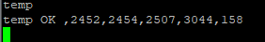
Returned values are:
Temperature t1,t2,t3 in counts, 100 counts = 1 degC
BatteryVoltage in mV
RSSI (receive signal strength indicator) of last communication

Send Direct Message
Send message from master to one slave. First parameter is master ID, then slave ID, then command. For example to send “temp” request to slave ID 13 (hex d): “tx 1,d,temp”
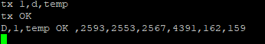
Last parameter appended to response is master’s RSSI value.
To send direct message to all boards specify ‘*’ as destination ID
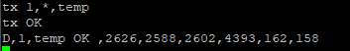
All boards that received request will send response.

Send mesh message to all boards to read temperature
Type “m”
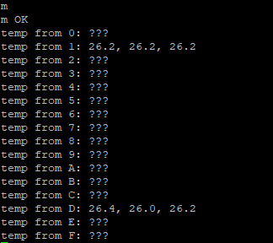

Turn motor
Specify direction and time in milisec
“left 1000” or “right 1000”


Read EERPOM settings
“logee”
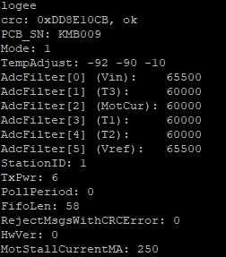

Change EEPROM value setting
Set ParamName value
Use command “logee” get parameter names
